**Gebze Technical University**

**Computer Engineering**

**CSE 222 - 2018 Spring**

**HOMEWORK 1 REPORT**

**AHMET ERGANİ**

**161044011**

Course Assistant: FATMANUR ESİRCİ

# INTRODUCTION

## Problem Definition

Like all modern hotels, Hotel California needs an interactive system that lets Guests book a room and lets the Receptionists check the guests in and out

## System Requirements

I designed a system that every guest needs to follow 2 steps in order to settle in a room.:

Booking and Checking In. According to my experience with hotels, an ordinary hotel system should allow a guest to book a room without coming to the hotel. However, system should not allow a guest’s check in operation to happen before his/her arrival to the Hotel. That’s where the receptionist intervene to the procedure. In an ideal hotel system, receptionist should ask for an ID card from the guest (who has already booked a room of course) and checks the records (.csv file). If a match occurs, receptionist should be able to easily check the guest in and the guest should be able to settle in his/her room without waiting at the lobby for a long time

# METHOD

## Class Diagrams

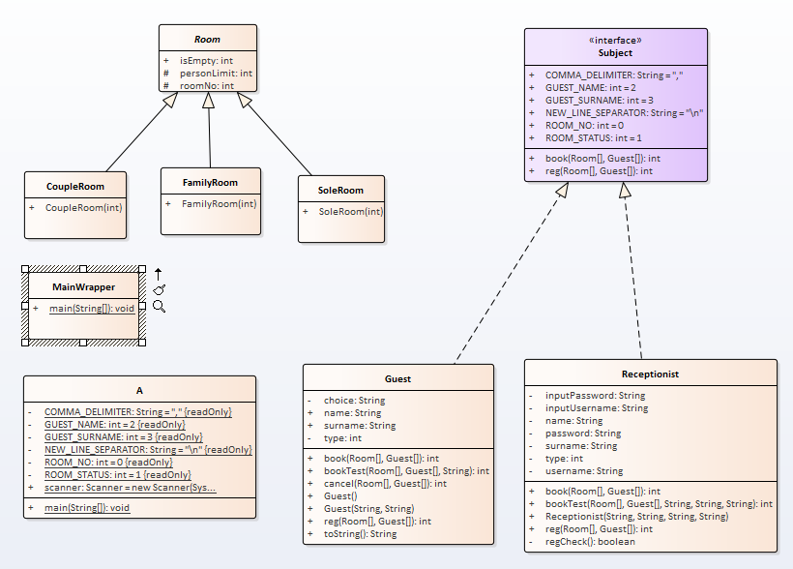

## Use Case Diagrams

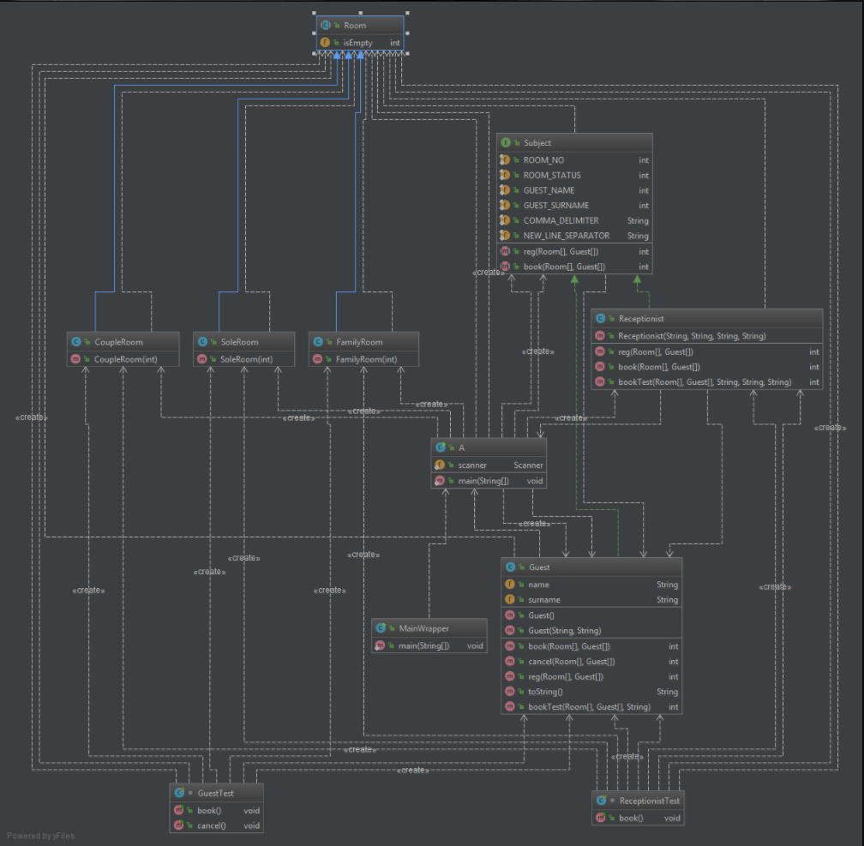

## Problem Solution Approach

I created an interface called “Subject” which has 2 methods : reg() and book() , then I created 2 classes that implements this interface

1-)Guest : Guest’s override of reg() method greets a guest, then asks the guest’s name and surname. After that it asks to guest what is his/her intention : “booking a room ?” or “cancelling a reservation ?” . If the guest chooses to book a room, reg() method calls the book() method ; else, the method calls the extra method cancel() (not in the interface).

Guest’s override of book() method informs the Guest about Room Types, scans the Hotel data, lists the available room types to the Guest and informs him about what to type for each room type.

Guest’s additional method cancel(), scans the Hotel Data and searches for a room that has been booked by that Guest. If a room like that exists, method empties the room and informs the guest about the succession of the operation

2-)Receptionist : Receptionist’s override of reg() method is for log-in procedure.Method asks for the staff number, username and password. After the method checks the input has been entered It calls the book() method of Receptionist class

Receptionist’s override of book() method asks for a Guest name. Then the method scans the Hotel data and if it founds that name there are 2 chances : Room can be booked by the Guest or room can be currently occupied by the guest. Then the Receptionist is asked if he/she wants to check the guest in if the guest has booked a room, or he/she wants to check the Guest out if the Guest is currently occupying a room

At last I created a class for Main and named it “A”.This class reads all the data from a csv file and fills an array of Rooms and an array of Guests according to that file. Then, this method proceeds to create the Receptionists while assigning their names,surnames,usernames,passwords (Hotel California has 3 receptionists).Finally it asks to user wheter he/she is a receptionist or a Guest. It deals with the rest by the methods of the classes that implements the Subject interface. You can use MainWrapper class to enter inputs from a file.

# RESULT

## Test Cases

Case 1 (1.txt) : A guest (who is also a receptionist) named Ahmet Ergani enters the system, types his name and books a Family Room.

Case 2 (2.txt) : A guest named Lev Tolstoy enters the system, types his name and books a Sole Room.

Case 3 (3.txt) : A receptionist named Ahmet Ergani enters the system,types his staff number, logs into the system and checks Ahmet Ergani (himself) in.

Case 4 (4.txt) : One of the Previous guests (Lev Tolstoy) enters the system, types his name and cancels his reservation.

Case 5 (5.txt) : Previous Receptionist (Ahmet Ergani) enters the system, types his staff number, logs into the system and checks Ahmet Ergani (himself) out.

## Running Results

Alihan Öztürk books a CoupleRoom

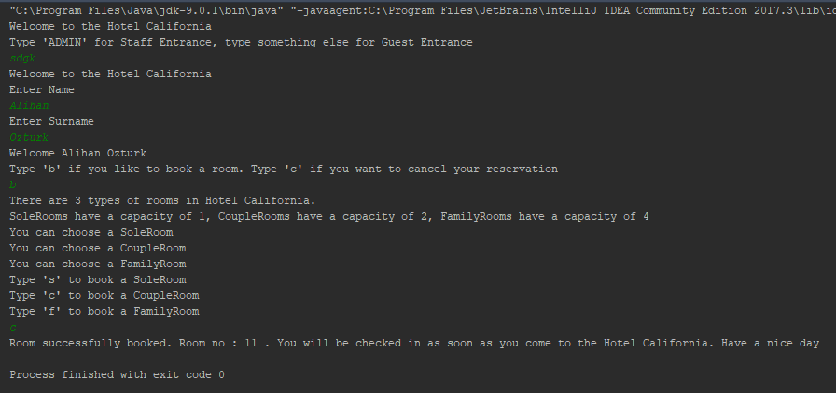

Receptionist Ahmet Ergani checks Alihan Öztürk in

